

High Level Design
Prepared by: Daniel Robledo Munoz | 10 February 2026

An Post – AWS Landing Zone



Contents

1. Document overview 5
1.1. Project Background 5
1.2. Document Purpose 5
1.3. Workload-Dependent Design Decisions 5

2. Solution Overview 6
2.1. What is an AWS Landing Zone? 6
2.2. Core Components 6
2.3. Logical Architecture 7
2.4. Multi-account Architecture 8
2.5. AWS Landing Zone – Organisational Units 9
2.6. AWS Landing Zone – Core Accounts 10
2.7. AWS Landing Zone – Primary AWS Services 11

3. Deployment approach 13
3.1. Landing Zone Accelerator (LZA) 13
3.2. Landing Zone Accelerator – Config Files 13
3.3. Landing Zone Accelerator – Deployment 14
3.4. Account Factory for Terraform (AFT) 14
3.5. AFT Repositories 15
3.6. Account Factory for Terraform – Deployment 16

4. Security 17
4.1. IAM Identity Center 17
4.1.1. SSO Login Page 17
4.1.2. Root Identities 18
4.1.3. Securing Root Identities 19

5. Cost Management 21
5.1. Consolidated Billing 21

Version Control
Date | Version | Changed By | Reason for Change
10/2/2025 | 0.1 | Daniel Robledo Munoz | Initial draft

Circulation List
Name | Organisation/Title
Karl Coffey | An Post / Chief Enterprise Architect
 | An Post /
Paul Hanover | Version 1 / Delivery Manager
Gerry Whelan | Version 1 / Enterprise Architect
Daniel Robledo Munoz | Version 1 / Cloud Architect
Shubham Narandekar | Version 1 / DevOps Engineer

Reference Documents
Title | Description | Owner
TBC | TBC | TBC

Document overview

Project Background

Capita had been hosting the PAD database owned by An Post, which was accessed by Autoaddress through a dedicated VPN connection. Following Capita’s withdrawal from the project, An Post has decided to assume full ownership of the platform by migrating the PAD database into a newly established AWS Landing Zone within its own environment. Our current engagement with An Post focuses on designing and implementing this AWS Landing Zone to accommodate the infrastructure previously managed by Capita. In addition, the new environment must incorporate the necessary endpoints that support the downloading of ECAD and ECAF files, ensuring continuity of service within the consolidated AWS ecosystem.

This document outlines the high-level design of the AWS Landing Zone for An Post. The Landing Zone provides the foundational architecture for securely hosting workloads in AWS, aligned with the AWS Well-Architected Framework. This architectural assessment evaluates the future implementation against five core pillars: Security, Operational Excellence, Reliability, Performance Efficiency, and Cost Optimization. The primary objective of this exercise is to identify areas for improvement, identify security vulnerabilities, and evaluate the long-term viability of both the application and its underlying platform.

The review surfaces several critical gaps spanning all five pillars. While some of these findings were specific to the application's immediate architecture and have since been addressed, a significant portion highlighted a broader lack of platform-level competency and consistent governance. The implementation of an AWS Landing Zone is proposed as the strategic solution to address and resolve these fundamental shortcomings, thereby establishing a more secure and scalable cloud foundation.

Document Purpose
This document is intended to provide a high-level, overarching view of the AWS Landing Zone solution and its core components.

Workload-Dependent Design Decisions

When navigating this document, please refer to the hand icon placed throughout. This icon indicates design decisions that are intentionally left open at this High-Level Design (HLD) stage, as they are dependent upon the onboarding of specific workloads and their individual requirements. These pending decisions will be addressed during the application onboarding phase to ensure alignment with application specific requirements.

Solution Overview

What is an AWS Landing Zone?

An AWS Landing Zone provides a standardized, secure, and automated foundation for all your cloud workloads. It's essentially a pre-configured AWS environment that sets up multiple accounts with built-in security and compliance controls, all aligned with the AWS Well-Architected Framework. This code-first approach ensures consistent configuration and governance across An Post’s entire AWS footprint.

Leveraging core AWS services such as AWS Organizations, AWS Control Tower, and AWS Config, an AWS Landing Zone will give An Post enhanced control and visibility over their AWS environment. From an Educational Technology perspective, this translates directly to reduced downtime, increased availability of essential learning applications, and a more secure, reliable platform for their educational needs.

Core Components

Organization | Role
Organization Structure | Multiple Organizational Units are deployed to provide a level of governance across multiple AWS accounts
Account Breakdown | AWS recommended multi-account approach is established to isolate workloads and environments
Security | AWS security services are deployed in every account and centralized in the dedicated Security OU
Identity & Access Management | IAM Identity Center provides SSO capabilities across all AWS accounts
Account Guardrails | Service Control Policies and AWS Control Tower guardrails are applied at the OU and account levels
Hub & Spoke Topology | A Hub VPC is deployed to facilitate a Hub & Spoke network topology
Firewall Capability | A firewall capability is deployed to route and inspect various traffic flows across the AWS estate by way of the AWS Network Firewall service
Centralized Logging | A centralized Log and Archive account collects and aggregates platform logs from across the Landing Zone
Cost Management | Billing and cost details are centralized in the Consolidated Billing Management account for invoicing, reporting, and alerting
Account Vending | New AWS account creation is automated via the Account Factory

Logical Architecture

The diagram below illustrates a logical architecture of the AWS Landing Zone with respect to the personas – Administrators, Platform Engineers and Developers - that operate at each layer: Management, Operations & Application Development.

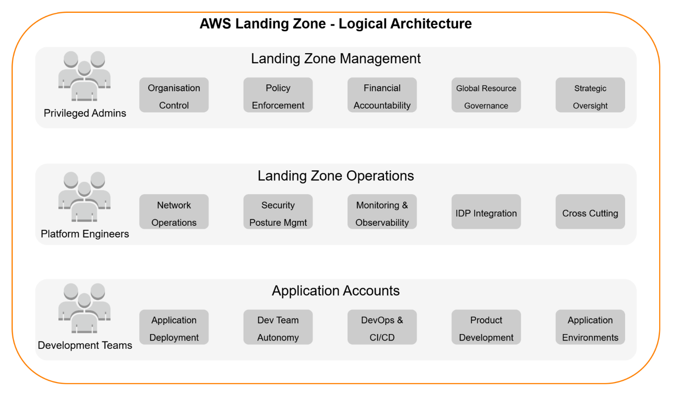
Figure 1 AWS Landing Zone - Logical Architecture

Multi-account Architecture

The diagram below illustrates the hierarchical multi-account Landing Zone architecture as well as the Organisational Units deployed as part of this engagement.

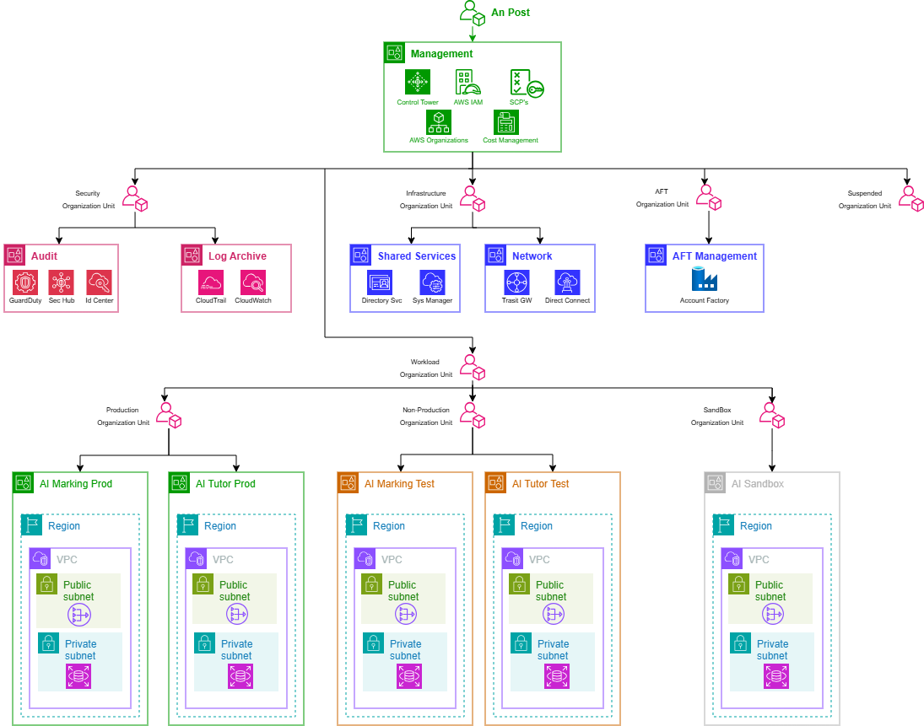

Figure 2 AWS Landing Zone - Account Hierarchy

AWS Landing Zone – Organisational Units

An Organisational Unit (OU) in AWS is a logical grouping of AWS accounts. It acts as a container that allows organisations to group and categorise multiple AWS accounts into a hierarchical structure.

The primary purpose of OUs is to simplify the management and governance of an AWS environment by applying common policies and controls to groups of accounts. This is particularly powerful when used with Service Control Policies (SCPs), which define the maximum permissions that can be granted within accounts belonging to a particular OU.

The following table describes the OUs deployed as part of the Landing Zone solution.

OU | Role
Management | The top-level Organisational Unit, primarily containing the AWS Organisations Management account. It serves as the administrative root for the entire multi-account environment, hosting core services that manage and govern the organisation.
Security | Dedicated to centralising security services and controls. It houses accounts for security auditing (i.e., Log Archive & Audit) and incident response, ensuring compliance monitoring and unified security posture across the organisation.
Infrastructure | Designed to host shared infrastructure accounts (e.g., Network, Shared Services). This OU contains resources and services that are common dependencies for multiple workloads and are managed centrally, such as Transit Gateways, shared VPCs, or (potentially) directory services.
Workloads | A logical grouping that serves as a parent container for accounts hosting application and service environments. It provides a hierarchical structure to organise various Sandbox, Test, and Production deployments.
Production | Contains AWS accounts specifically allocated for live, mission-critical application deployments. This OU is subject to the most stringent security, operational, and change management controls to ensure stability and compliance for Production workloads.
Non-Production | Houses AWS accounts designated for development, testing, staging, and quality assurance environments. Controls here are typically more relaxed than in Production, allowing for agility in development while still maintaining a secure baseline.
AFT | An OU specifically designated for accounts provisioned and managed by AWS Control Tower's Account Factory for Terraform. It facilitates automated, customised account creation and lifecycle management through Infrastructure as Code.
Sandbox | Provides isolated AWS accounts for experimental development, proof-of-concept work, and learning. These accounts offer a high degree of autonomy to users (Developers and Engineers) but are typically subject to strict cost controls and are isolated from production environments.

AWS Landing Zone – Core Accounts

The following table describes the primary AWS accounts deployed as part of the Landing Zone solution.

Account / ID | OU | Role
Root /  Acc. Id | Root | This is the primary account of the AWS Organisation and the central point for billing, Service Control Policies (SCPs), and overall management of other AWS accounts. This account hosts the core Landing Zone Accelerator pipeline and automation services (CodePipeline, CodeBuild, Lambda functions) responsible for vending and governing new accounts (via AWS Control Tower’s Account Factory service), as well as managing the organisational structure.
Audit /  Acc. id | Security | A highly restricted, dedicated account for centralising all security and compliance-related logs and resources. This includes consolidating AWS Config recordings, GuardDuty findings, Security Hub aggregates, and other security service outputs from all accounts across the organisation. Access to this account is limited to security and compliance personnel only.  It also integrates with AWS IAM Identity Center (formerly SSO) for centralised access management.
Log Archive /  Acc. Id | Security | A dedicated account for long-term, immutable storage of all organisational and operational logs. This includes CloudTrail logs, S3 access logs and VPC Flow Logs. Its primary purpose is secure, centralised, and immutable log retention for compliance, auditing, and troubleshooting.
Network /  Acc. Id | Infrastructure | Dedicated for centralising network infrastructure that spans multiple accounts across the entire organisation. This includes AWS Transit Gateway (for inter-VPC routing), centralised egress points, and shared DNS services. Consolidating networking here simplifies management and enhances security.
Identity /  Acc. Id | Infrastructure |   TBC – an An Post wide design decision is required to assess whether a centralised Identity account is warranted to manage the creation of AWS Cognito pools.  A dedicated account to facilitate federated identities from a centralised IDP e.g. OneLogin & ClassLink. This account will host AWS Cognito pools which applications (AI Tutor, AI Marking) will interface with to provide an authentication layer.
Account Factory /  Acc. Id | AFT | A dedicated account to host services associated with account provisioning using Account Factory for Terraform (AFT). This will host the AFT related AWS CodePipeline and AWS CloudFormation Stacks that will consume the Terraform configuration and generate workload AWS accounts (AI Marking Test, AI Marking Production accounts) and any customisation configuration.

AWS Landing Zone – Primary AWS Services
The following table describes the primary AWS services deployed as part of the Landing Zone solution.

AWS Service | Role
AWS Organizations | This is the foundational service for managing multiple AWS accounts. It facilities the consolidation and management of multiple AWS accounts under a single, unified billing and management entity. Its primary purpose is to help An Post centrally govern the AWS estate as it scales.  AWS Organisations is primarily configured and managed from the Management Account.
AWS Control Tower | AWS Control Tower builds on AWS Organisations to set up and govern a secure, multi-account AWS environment i.e. the Landing Zone, according to best practices. It automates the setup of the platform’s core accounts (Management, Log Archive and Audit accounts), configures guardrails (both preventative and detective), and provides a dashboard for continuous monitoring and compliance. It acts as an orchestration layer for many underlying AWS services.  AWS Control Tower is deployed and managed from the Management Account. When set up, it automatically provisions the Log Archive and Audit accounts
Account Factory | The Account Factory is a feature of AWS Control Tower that automates the provisioning of new AWS accounts that are pre-configured with your organisation's established baseline (e.g., connected to AWS Organizations, enrolled in Control Tower's guardrails, pre-integrated with central logging and auditing). This ensures consistency and compliance for every new account from day one.  Terraform will be leveraged to manage Account Factory to create new application-level accounts. The new accounts themselves are created as Member Accounts under the organisation.
AWS Config | AWS Config provides a detailed inventory of your AWS resources, tracks their configuration changes over time, and evaluates these configurations against desired rules (e.g., "S3 buckets should not be publicly accessible").  AWS Control Tower automates the deployment of Config rules from the Audit account. AWS Config is enabled in each Member Account to record local resource configurations. However, to provide a layer of observability across all accounts, its findings and configuration history are aggregated centrally in the Audit account.
Service  Control Policies | SCP’s are a type of organisation policy that provide a mechanism for managing permissions across the AWS organisation. They provide centralised control over the maximum available permissions for all accounts in your organisation or specific Organisational Units (OUs). SCP’s do not grant permissions; rather, they set guardrails by defining what actions users and roles within member accounts are prevented from doing, even if an IAM policy in that account explicitly grants the permission.
Identity Center | Centralises access management to all accounts within the AWS Organisation. It enables single sign-on access to AWS accounts and any applications using an existing corporate directory (e.g., Active Directory) or its own managed directory. It defines permissions at a centralised level and propagates them across the various member accounts via permission sets.
Security Hub | Provides a comprehensive view of the overall security posture across the Landing Zone. It collects security findings from various AWS services (GuardDuty, Config), aggregates them, and provides automated security checks against best practices and compliance standards.

Deployment approach

Landing Zone Accelerator (LZA)

The AWS Landing Zone Accelerator (LZA) is an open-source solution designed to automate the rapid deployment of a secure, scalable, and compliant multi-account AWS environment. Built upon AWS best practices and aligning with various global compliance frameworks, LZA leverages Infrastructure as Code (IaC) principles through AWS Cloud Development Kit (CDK) and a set of YAML configuration files.
It extends the foundational capabilities of AWS Control Tower by providing enhanced customisation for security controls, network topology centralised logging, auditing, and automated account provisioning. This significantly reduces the upfront manual effort in establishing a cloud foundation, enabling An Post to accelerate their cloud adoption while maintaining strict governance and security posture.

Landing Zone Accelerator – Config Files

At the heart of the AWS Landing Zone Accelerator solution are six YAML configuration files: accounts-config.yaml, global-config.yaml, iam-config.yaml, network-config.yaml, organisation-config.yaml, and security-config.yaml. These declarative files serve as the primary interface for An Post to define and customise the desired multi-account AWS environment.Therefore, the solution warrants a dedicated GitHub repository to version control these configuration files. The table below captures the GitHub repo and link to same.

Repo Name | GitHub Link
ap_aws_landing_zone_configuration | TBC

Landing Zone Accelerator – Deployment

The diagram below illustrates a high-level overview of how the An Post managed Landing Zone Configuration repository relates to the AWS components that comprise the Landing Zone solution.

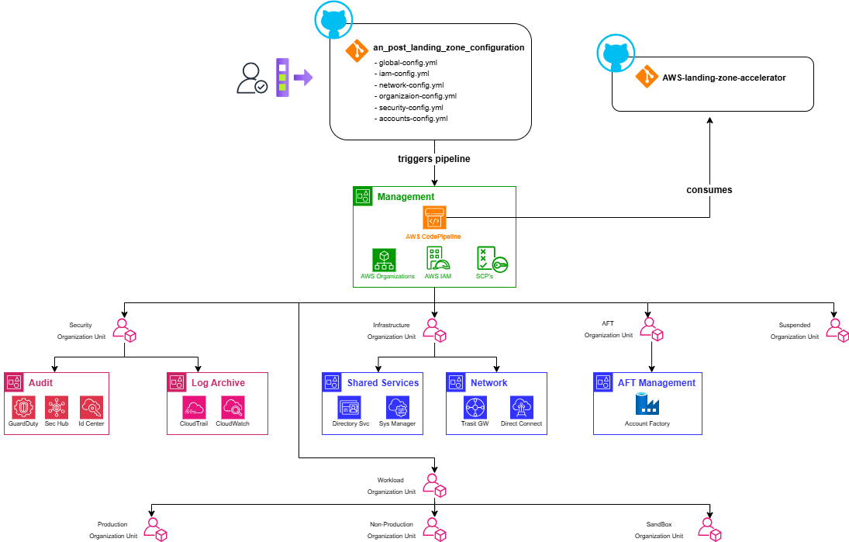

Figure 3 Landing Zone Accelerator - Deployment

Account Factory for Terraform (AFT)

While the AWS Landing Zone Accelerator (LZA) focuses on deploying a comprehensive, compliant multi-account baseline, Account Factory for Terraform (AFT) serves a distinct, complementary purpose.

AFT is an open-source solution built on top of AWS Control Tower that specifically leverages Terraform (HashiCorp’s IaC tool) to automate the provisioning and customisation of individual AWS accounts. Unlike LZA, which establishes the overarching foundational infrastructure and governance of the Landing Zone itself using AWS CDK and YAML configurations, AFT provides a GitOps-driven pipeline for self-service account vending, enabling An Post’s Cloud Platform team to procure new, pre-configured accounts in compliance with established guardrails.

This distinction means the LZA builds the foundation, while AFT provides the automated "factory" to rapidly spin up new accounts within the established foundational structure, offering greater flexibility for teams who prefer Terraform for their infrastructure deployments.

Account Factory for Terraform (AFT) offers distinct advantages beyond merely supporting Terraform-proficient teams:
- AFT mitigates operational risk by separating the provisioning of individual member accounts from the broader landing zone deployment.
- Smaller Blast Radius:
  - The AWS Landing Zone Accelerator (LZA) relies on a highly complex CodePipeline instance to manage the entire multi-account environment. A misconfiguration or issue within the LZA's core pipeline could have a wide-ranging, detrimental impact across the entire AWS Organization.
  - In contrast, AFT's pipelines are specifically focused on vending and customising individual member accounts. A misconfiguration within an AFT process is scoped primarily to the specific account(s) affected, significantly limiting the potential "blast radius" to individual member accounts rather than the foundational Landing Zone itself.
- AFT provides a more agile and resilient workflow for routine account creation, reducing the need to frequently interact with or re-execute the more complex and comprehensive LZA pipeline for this specific task.

AFT Repositories

Repo Name | GitHub Link
<TBC>_aws_lz_aft_account_request | https://github.com/<repository_name>/ <TBC>_aws_lz_aft_account_request
<TBC>_aws_lz_aft_global_customizations | https://github.com/<repository_name>/  <TBC>_aws_lz_aft_global_customizations
<TBC>_aws_lz_aft_account_  provisioning_customizations | https://github.com/<repository_name>/ <TBC>_aws_lz_aft_account_provisioning_customizations
<TBC>_aws_lz_aft_account_customizations | https://github.com/<repository_name>/ <TBC>_aws_lz_aft_account_customizations
<TBC>_aws_account_factory_vending | https://github.com/<repository_name>/  <TBC>_aws_account_factory_vending

Account Factory for Terraform – Deployment

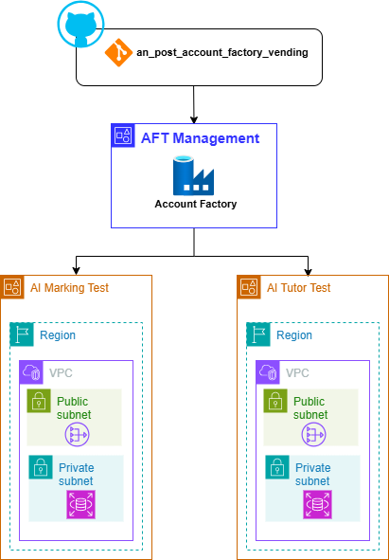

Figure 4 AFT - Deployment

Security

IAM Identity Center

IAM Identity Center (formerly AWS Single Sign-On) will be leveraged to provide a streamlined and secure method for managing access across the multi-account AWS environment.
- The Landing Zone Accelerator creates an IAM Identity Center instance in the AWS Management account. This service facilitates Single-Sign On for all AWS users which is especially pertinent when working in a multi-account structure. The introduction of this service negates the need to create and manage separate IAM users in each individual account, significantly reducing administrative overhead.
- It facilitates a seamless Single Sign-On experience for all AWS users. Users log in once to a central user portal with their credentials and can then securely access all assigned AWS accounts and roles without re-authenticating.
- When new users are created an invitation process guides them through password setup and mandatory Multi-Factor Authentication (MFA) configuration. This ensures a standardised, secure, and automated onboarding experience. Conversely, centralised management simplifies rapid offboarding and access revocation.
- Access to AWS accounts is managed through Permission Sets. These define specific AWS IAM policies and permissions (e.g., Administrator Access, Read-Only, Developer Access) that are then assigned to users or groups. IAM Identity Center automatically provisions and manages corresponding IAM roles in each target AWS account, ensuring consistent application of the principle of least privilege across your organisation.
- The management of new identities, existing identities and associated permissions is all managed under IAM Identity Center console.


For the initial Landing Zone implementation, IAM Identity Center will be configured to provide Single Sign-On (SSO) capabilities across all member accounts within the AWS Organisation, with users managed directly within Identity Center's own directory. The primary purpose at this stage is to centralise user access and streamline login to AWS accounts. This baseline configuration does not include integration with external Identity Providers (IdP) or the development of custom IAM roles via Identity Center.

SSO Login Page
The table below captures the SSO login page for accessing the various AWS accounts deployed as part of the Landing Zone.

Description | Link
An Post AWS LZ SSO Landing Page | https://<TBC>

Root Identities

When a new AWS account is created, whether it's a standalone account or part of an AWS Organization, a unique root user identity tied to an email address is a mandatory requirement to complete the process. For An Post’s AWS Landing Zone, all of the core Platform AWS accounts will leverage the "plus addressing" feature of the Management account's email address.
This strategy ensures that the root user email for every core Platform AWS account adheres to a consistent and easily identifiable naming convention:
<management_account_email>+<AWS_Account Name>@anpost.ie. For example, since the Management account's email is <TBC>@anpost.ie, the root user email associated with the Landing Zone’s Network account is <TBC>+network@anpost.ie.
Similarly, the root user email associated with the Log Archive AWS account is <TBC>+logarchive@anpost.ie.
This method offers several benefits for managing a multi-account AWS environment:
- All root user emails for various accounts route to a single, controlled inbox associated with the Management account. This simplifies monitoring and significantly reduces the administrative overhead of managing separate mailboxes for each account.
- By centralizing email reception, it becomes easier to secure the primary email inbox, thereby safeguarding the recovery mechanism for all root users across the organization. This reduces the attack surface compared to scattering root user emails across multiple, potentially less secure, individual mailboxes.
- In the event of a lost root user password or compromised credentials for any member account, the password reset emails are delivered to the designated Management account inbox, facilitating a quicker and more controlled recovery process.
- Having a consistent and predictable naming pattern for root user emails aids in auditing and tracking account ownership and communication.


For all workload AWS accounts deployed to the Landing Zone, a new Shared mailbox will be generated to mitigate against any security compromises relating to the Shared mailbox configured on the Platform level AWS accounts i.e. apawslz@anpost.ie, providing a layer of demarcation between workload and Platform level AWS accounts.

For AWS accounts deployed via the Platform config repository e.g. Network account, Audit account:
- An SSO Identity is automatically generated for each account, except for the Audit and LogArchive accounts. These two accounts only have a root user email address; they do not get an SSO identity.

For AWS accounts deployed via the Account Factory for Terraform (AFT) managed repository:

- Both a root user identity and an SSO root user identity are generated.
- This dual identity approach significantly enhances security by minimizing direct root user logins. Instead, users can access the new AWS account via an automatically generated IAM Identity Center user, which aligns with AWS best practices. This automated creation streamlines access, saves time, and provides the flexibility for distinct email addresses for the root and SSO users.

AWS Account | Root User Identity | SSO Identity
Management | apawslz@anpost.ie | apawslz@anpost.ie
Audit | apawslz+audit@anpost.ie | N/A
Log Archive | apawslz+logarchive@anpost.ie | N/A
Network | apawslz+networking@anpost.ie | apawslz+networking@anpost.ie
Identity | apawslz+identity@anpost.ie | apawslz+identity@anpost.ie
AFT Management | apawslz+aft@anpost.ie | apawslz+aft@anpost.ie

Securing Root Identities

While the root user of each AWS account in the Landing Zone should be used sparingly, securing the root email address and its associated identity is crucial for maintaining the overall security posture and ensuring a recovery mechanism for the multi-account environment. This email address serves as the primary recovery point for the account's root user credentials, making its compromise a critical threat that could lead to unauthorised access and control over AWS resources.
To achieve robust security for these critical root email identities, a standard process should be rigorously followed for each new account provisioned within the Landing Zone:
- Accept invitation: Upon account creation and its invitation to the AWS Organisation, the root user associated with the unique email must accept the invitation. This involves a first-time login to the AWS Management Console for that specific account e.g. apawslz+network@anpost.ie
- Initial login: After the initial login, the default or temporary password must be immediately changed to a strong, complex, and unique password. This new password should never be shared verbally or stored insecurely.
- Securely store password: The new password for each account's root user must be stored securely in an enterprise-grade password manager.
- MFA: Multiple MFA devices (e.g., multiple virtual MFA applications on different trusted individuals' phones) should be registered to each root user. This redundancy ensures that if one device is lost or inaccessible, there are still alternative authorised MFA devices to regain access.
- Shared Mailbox: The use of "plus addressing" (e.g., apawslz+network@anpost.ie) routes all root user emails to a designated, shared mailbox (i.e., apawslz@anpost.ie). This centralises the receipt of critical notifications for all accounts.
- Forwarding Rules: (Optional, but recommended) To mitigate the risk of important emails being lost or unread in a shared mailbox that might not be frequently checked, configure automated forwarding rules. These rules should forward all incoming emails from the root email addresses to a distribution list of relevant administrators (e.g., a DL containing Vik, Matt, Craig & Stuart) or integrate with a centralised alerting system (e.g., Microsoft Teams). This ensures that critical alerts are pushed to the relevant personnel's personal inboxes or collaborative channels, requiring no explicit action to "check" the shared mailbox and dramatically reducing the chance of missing vital communications.

Cost Management

Consolidated Billing
The consolidated billing feature in AWS Organisations consolidates billing and payment for multiple AWS accounts. The AWS Management account is responsible for paying the charges of all member accounts.
Consolidated billing has the following benefits:
- One bill – You get one bill for multiple accounts in the same Source of Record. If an organization has accounts from multiple SORs, you receive one bill per SOR.
- Easy tracking – You can track the charges across multiple accounts and download the combined cost and usage data.
- Combined usage – You can combine the usage across all accounts in the organisation to share the volume pricing discounts, Reserved Instance discounts, and Savings Plans. This can result in a lower charge for your project, department, or company than with individual standalone accounts.
- No extra fee – Consolidated billing is offered at no additional cost.
- You can see a combined view of the AWS charges that the member accounts incur. You also can generate a cost report for each member account.


For more information,
please visit version1.com
Thank you

